Grading Policy 2023 - 2024

Timeline of When Students Receive Grades

WHEN AND HOW WILL STUDENTS AND FAMILIES RECEIVE GRADES?

- Each school year has 2 semesters- Fall and Spring. Final grades for each course are based on a grading system, which will appear on student’s official transcript at the end of each semester.
  - Fall Semester consists of 3 marking periods ending:
    - 10/20/23
    - 12/01/23
    - 01/22/24
  - Spring Semester consists of 3 marking periods:
    - 03/15/24
    - 05/03/24
    - 06/13/24

- Marking period end dates may require minor adjustments in response to unexpected calendar changes that could occur during the year. Any revisions will be announced in advance and shared with families prior to a calendar update.

- A parent(s)/guardian(s) can access student’s up to date grades via new online grading system. Username and passwords are distributed to each of the students to present to their parent/guardian at the beginning of the academic year or when ly admitted. A letter with this information is also sent home via mail/email.
- Report Cards Distribution Date:
  - Report cards will be available in Pupil Path and your child’s NYC student account. Students are also expected to present their report card to their parent(s)/guardian(s).
    - Fall Semester:
      - 10/27/23
      - 12/08/23
      - 01/30/24
    - Spring Semester:
      - 03/22/24
      - 05/10/24
      - 06/26/24

WHEN AND HOW CAN GRADES BE CHANGED AFTER THEY HAVE BEEN FINALIZED?

- Grade changes permitted through Transcript Update Guideline Procedures per Academic Policy.

- School wide Grading Rubric as per content area:

Full Assessment
(Unit exam, Discovery/Research-Based Project Inquiry Tasks,
Mid-Term, Final Exam)
40%

Mini Assessment
(Quizzes, Mini Projects & Other Assignments)
25%

Participation
(Effort, growth, academic improvement, punctual, improved attendance, revising work for mastery, completing lesson activities such as do now, exit ticket, etc., participating in classroom discussion, and group/ partner collaborations)
20%

Homework
(Assignments/practice tasks completed outside the classroom)
15%

Scale of Marks Awarded
WHAT IS THE SCALE OF MARKS USED TO AWARD GRADES?
Passing grades are 65-100 and are issued in increments of one from 65, 66, 67, 68, etc...
There are no single increments from 56-64.
For marking periods 1 and 2 there is an option to issue "60" for any student that falls between a 56-64.
The 60 is listed as failing with the potential to pass the next marking period.
Failing grade for academic reasons remains a 55.

WHAT IS THE RANGE OF MARKS THAT CAN BE AWARDED?
- A student can receive any range of marks from the scale mentioned above.

  - “NS ”: A student who receives an “NS” has been identified as a “No Show.” A “No Show” is a student who has attended one day or less of a course since being admitted into school. An “NS” equates to a 45.

  - “55”: A student who receives a 55 has attended a course at least twice and has not meet the teachers/school grading rubric for obtaining at least a 60.

  - “60”: A student who receives a 60 in marking periods 1 or 2 of the fall or spring semester has the potential to pass the final marking period.

  - “65 – 100”: A student who receives a grade between 65 – 100, has received this grade as an actual grade within the teachers/school grading rubric. This grade range is passing and a student will be rewarded credit value assigned to course.

  - “P”: A student who receives a grade of P, has received this grade as an actual grade within the teachers/school grading rubric. This grade range is passing and a student will be rewarded credit value assigned to course.

  - NX: A student who receives a grade of NX has not been able to complete his/her course hours and/or mastery due to unforeseen circumstances. This is an incomplete grade code. (Teachers are required to work with any student who needs to make up incomplete coursework. This coursework and a Grade Update form must be submitted by the subject teacher and approved prior to the last day of the following semester.)

  - NL: A student who receives a grade of NL has not been able to complete his/her course hours due to being a new admit to this school. This is an incomplete grade code. (Teachers are required to work with any student who needs to make up incomplete coursework. This coursework and a Grade Update form must be submitted by the subject teacher and approved prior to the last day of the following semester.)

WHAT IS THE MINIMUM GRADE A STUDENT MUST RECEIVE TO PASS A COURSE?
- “65”: The minimum passing numeric grade a student can receive is a 65.
- “P”: The minimum passing alpha grade a student can receive is a P.
- “S”: ONLY USED for Lab Course Sections: The minimum passing alpha grade a student can receive is a S.

WHAT IS THE LOWEST GRADE A STUDENT CAN EARN?
- “NS”: The minimum failing numeric grade a student can receive is a 45.
- “F”: The minimum failing alpha grade a student can receive is a F.
- “U”: ONLY USED for Lab Course Sections: The minimum failing alpha grade a student can receive is a U.

- HOW ARE GPA AND CLASS RANK CALCULATED?
- Grade Point Average (GPA):
  - A GPA is calculated through courses which are identified as all credit bearing courses with exception of Physical Education and courses marked with the asterisk symbol (*) as identified on student transcript.
  - GPA is weighted according to type of course:
    - Honors Course is identified with an “H” at the end of a course code on a transcript. It is weighted at 1.05.
    - Advanced Placement Course is identified with an “X” at the end of a course code on a transcript. It is weighted at 1.10.
    - Preparatory/Audit Course is identified with a “P” at the end of a course code on a transcript. It is not averaged into the students GPA.
- Class Rank:
  - Class rank is calculated per GPA with each student only receiving one rank number.

Credit is awarded as follows:

- Students earn credit per semester based on hours of study as per city and state academic policy
- Examples but not limited to:
  - Major Subjects: 54 hours of study equals one (1) credit per course
  - Physical Education is awarded .58 per semester due to a student taking the course 5 days a week. This allows the student per to take not take PE during one semester in which the Health course is taken at 1 credit value.
- Each school year has 2 semesters- Fall and Spring. Final grades for each course will appear on student’s official transcript at the end of each semester.
CAN A STUDENT DROP OR ADD A COURSE?
A student’s course schedule is the result of careful planning involving students, counselors, and teachers. Course offerings and staffing decisions are planned based on student course requests; therefore, once a student’s program is developed, changes are discouraged. Students should consider their course selections carefully each semester.

Requests for changes once the course selection process is over must follow the steps detailed below:

Requests for changes will not be considered for any of the following reasons:
- Change teachers.
- Change lunch periods (unless supported by medical documentation).
- Change to a more convenient and/or desirable period.
- Group friends together in the same class.

Process for requested schedule changes:
- Student picks up a Student Add-Drop Class Form from his/her Guidance Counselor and discusses the possible changes.
- Student discusses changes with parent/guardian and returns form signed by parent/guardian to Guidance Counselor.
- Form is submitted to an Assistant Principal or Principal for approval.
- No schedule change will be made without an administrator’s signature.

Please note the following conditions of a course change:
- Changes will only be considered during the first 7 business days of each semester.
- Students must remain in the original class until notified by their counselor.
- For a level change, the grade in progress will follow the student to the new class.
- Requests to change elective classes will generally not be addressed.
- The student’s schedule may have to be completely revised to accommodate the change.

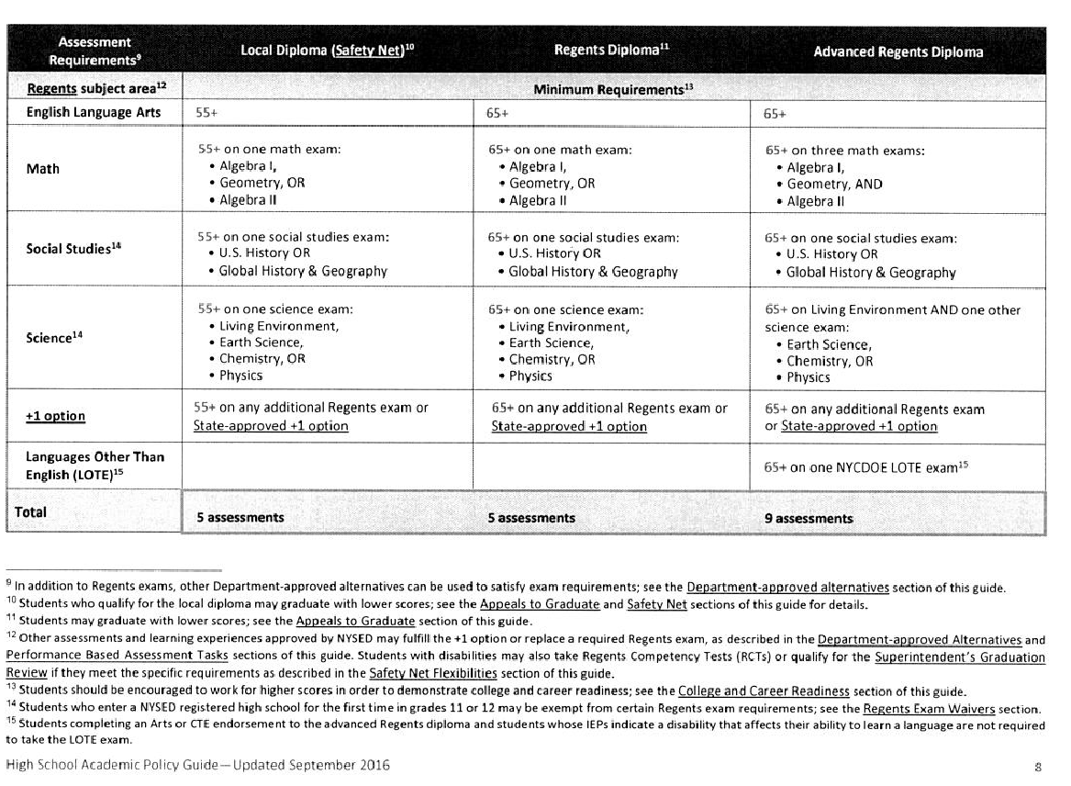

Implementation

- WHO DOES THE GRADING POLICY APPLY TO?
- Grading Policy is School wide Grades 9-12.

ARE THERE OPPPORTUNITIES TO DISCUSS STUDENT PROGRESS WITH FAMILIES?

- For the 2022-2023 school year, parents are invited to discuss student progress during virtual parent teacher conferences on dates:
11/16/23, 11/17/23, 3/21/24, 3/22/24
- Private individual conferences scheduled with specific teachers through ongoing parent outreach.
- New online grading system can be accessed by both parents and students and is also be a source of parent/teacher communication.

WHEN WILL THE GRADING POLICY BE REVIEWED AND UPDATED?

- Grading Policy will be updated and reviewed annually.
- Changes will be posted as dated addendums
- All changes will be included in the most up to date comprehensive school wide grading policy

Other Considerations

IN WHICH FORMAT(S) AND THROUGH WHICH COMMUNICATION CHANNEL(S) WILL THE GRADING POLICY BE AVAILABLE TO STUDENTS AND FAMILIES?

- Students will receive a copy at the beginning of the school year and it will also be made available on the Veritas website.

WHAT OPPORTUNITIES DO TEACHERS HAVE TO SHARE THEIR INDIVIDUAL GRADING POLICIES WITHIN AND ACROSS TEAMS? ARE THEY REVIEWED ANNUALLY OR ONLY WHEN UPDATED?

- Lead teachers meet with teacher teams at the start of each school year to discuss and share individual grading policies. They are reviewed throughout the school year and updated as needed.

HOW ARE FINAL GRADES CALCULATED?

- Final grades for each semester are calculated in new online grading system .

ARE THERE COURSES WHERE STUDENTS ARE PASSING OR FAILING SOLELY BECAUSE OF FACTORS LIKE ATTENDANCE, BEHAVIOR, CONDUCT, AND PARTICIPATION? ARE STUDENTS PASSING OR FAILING BASED ON HOW WELL THEY DEMONSTRATE THEIR MASTERY OF THE CONTENT AND SKILLS REQUIRED IN THAT SUBJECT?

- Students pass courses based on how well they demonstrate mastery and skills of the content subject area.

DOES YOUR SCHOOL AVERAGE MARKING PERIOD GRADES TOGETHER TO CREATE THE FINAL COURSE GRADE, OR IS THE FINAL COURSE GRADE CUMULATIVE?

- Student grades are not cumulative.

DOES YOUR SCHOOL PROVIDE PERSONALIZED FEEDBACK TO STUDENTS IN ADDITION TO GRADES? IF SO, HOW (EG. USE WRITTEN NARRATIVES AND/OR COMMENT CODES IN REPORT CARDS?)

- Students are provided personalized feedback through content area rubrics. Students are also given feedback through new online grading system accounts.

WHAT IS THE TIME FRAME AND MANNER IN WHICH STUDENTS CAN SUBMIT MAKEUP AND LATE WORK? ARE THERE DIFFERENT CONSIDERATIONS IF A STUDENT IS SUBMITTING MAKEUP WORK DUE TO AN ABSENCE VS. NON-COMPLETION?

- Makeup assignments and late work will be accepted no later than the end of each marking period and only work for that marking period. Only students with excused absences will be given an opportunity to make up any missing or incomplete assignments. Students with confirmed cuts will receive a grade of zero for any missed assignment and/or exam.
- All missing assignments will receive a grade of zero after the due date. The zero will then be reversed with an appropriate grade when the missing work is made up.
- Work handed in past due dates will be penalized with grade point deductions. On a grade scale of 100, any assignment up to one week late will be penalized by 10 points, any assignments after that and before the marking period ends, will be penalized 15 points. If the late assignment is not on a scale of 100 the penalties would be issued in the equivalence of percentages of 10 or 15 percent for each time interval.
- Grade updates made within 10 school days of the last day of the current semester can be updated by the teacher with evidence of the reason for the grade change. Transcript updates made after 10 school days of the final day of the current semester must be made before the last day of the following semester and grade update paperwork must be completed.

WHAT MARKS CAN BE AWARDED IF THERE IS NOT ENOUGH STUDENT WORK TO DETERMINE MASTERY?

- “NS”: A student who receives an NS has been identified as a “No Show.” A “No Show” is a student, who has attended one day or less of a course since being admitted into school. An “NS” equates to a 45.

- “55”: A student who receives a 55 has attended a course at least twice and has not meet the teachers/school grading rubric for obtaining at least a 60.

- “60”: A student who receives a 60 in marking periods 1 or 2 of the fall or spring semester has the potential to pass the final marking period.

- NX: A student who receives a grade of NX has not been able to complete his/her course hours and/or mastery due to unforeseen circumstances. This is an incomplete grade code. (Students are able to coordinate with the subject teacher in order to make up the incomplete coursework in an effort to receive a passing grade. This coursework and a Grade Update form must be submitted by the subject teacher and approved prior to the last day of the following semester.)

- NL: A student who receives a grade of NL has not been able to complete his/her course hours due to being a new admit to this school. This is an incomplete grade code. (Students are able to coordinate with the subject teacher in order to make up the incomplete coursework in an effort to receive a passing grade. This coursework and a Grade Update form must be submitted by the subject teacher and approved prior to the last day of the following semester.)

How and when can students receive grades (NX, NL, NS,) in your school?

Under what circumstances are those marks determined?

- “NS”: A student who receives an NS has been identified as a “No Show”. A no show is a student, who has attended one day or less of a course since being admitted into school. An “NS” equates to a 45.

- NX: A student who receives a grade of NX has not been able to complete his/her course hours and/or mastery due to unforeseen circumstances. This is an incomplete grade code. (Students are able to coordinate with the subject teacher in order to make up the incomplete coursework in an effort to receive a passing grade. This coursework and a Grade Update form must be submitted by the subject teacher and approved prior to the last day of the following semester.)

- NL: A student who receives a grade of NL has not been able to complete his/her course hours due to being a new admit to this school. This is an incomplete grade code. (Students are able to coordinate with the subject teacher in order to make up the incomplete coursework in an effort to receive a passing grade. This coursework and a Grade Update form must be submitted buy the subject teacher and approved prior to the last day of the following semester.)

How and when can those marks be updated with a new final grade?

- Students who receive a grade of 60 -64 or a grade of NX or NL in the final marking period of Semester I or Semester II, will be given an opportunity to make up any missing or incomplete assignments.

- Grade updates made within 10 school days of the last day of the current semester can be updated by the teacher with evidence of the reason for grade change.

- Transcript updates made after 10 school days of the final day of the current semester must be made before the last day of the following semester and grade update paperwork must be submitted with attached evidence to support the grade change and must be approved by administration prior to the grade being updated.

- Students who receive a U for Science labs in Semester I will be given the opportunity to make up any missing labs in Semester II. This will allow students to receive a Satisfactory for the year and permit the student to sit for the June Regents Exam.

ARE REGENTS EXAMS WEIGHTED IN THE FINAL GRADE? IF SO, HOW?
(NOTE: REGENTS MAY ONLY BE WEIGHTED UP TO 33% OF THE FINAL GRADE.)

- Regents grades are NOT calculated as part of final semester grade.

Promotion in Doubt Rubric

Cohort III – 9th Grade Student
- Failing English or
- Failing Social Studies or
- Failing any 2 Subjects
Cohort II – Expected 10th Grade Student
- Failing English or
- Failing Social Studies or
- Failing any 2 Subjects or
- Has 7 or Less Credits
Cohort I– Expected 11th Grade Student
- Failing English or
- Failing Social Studies or
- Failing any 2 Subjects or
- Has 19 or Less Credits
Cohort Z – Expected 12th Grade Student
- Failing English or
- Failing Social Studies or
- Failing Physical Education or
- Failing any 2 Subjects or
- Has not meet 4+1 Regents Requirements or
- Has 32 or Less Credits
Second Marking Period 2 of Term 1 report cards will be utilized to make the above determination. When appropriate, the content area departments will also review students scheduled to receive a PID and make recommendations. Most current available transcripts, prior to recording PID will be reviewed for credits mentioned above. Furthermore, students who have not met 4+1 Regents requirements by the 12th grade will also receive a PID letter. Any juniors who are far behind in meeting Regents Requirements will also be sent a PID letter.

Notes:

- Regents exams may be re-taken in order to achieve a passing grade of 65 or higher.

- Advance Placement exams may not be repeated.

- Approved grade changes are teacher initiated with proper written documentation of rationale including but not limited to Gradebook provided within 10 days of entering report card grades at the end of the marking period.

- Credit recovery is NOT offered in the form of condensed coursework, with the exception of summer school when available.

- Students who fail courses/ credits required for graduation must make up missing credit.
  - Courses may be repeated until passed. Priority is given to graduating cohort students first, of current school year.

Academic Integrity Policy

Veritas Academy, in its mission to find and ignite the gifts of every student, takes seriously the matter of academic dishonesty. Each individual act of plagiarism or cheating by a Veritas student impact the entire school community. It unfairly rewards those students who cheat, and hurts honest students’ chances of acceptance into specialized courses and colleges. This inequality, in turn, discourages honesty and spawns further dishonesty. Academic dishonesty undermines Veritas’s mission of inquiry, informed decision, self-awareness, and empathy, and replaces it with distrust and vitriol amongst students, faculty and administration, as well as tarnishes Veritas’s reputation as a whole. Examples of academic dishonesty include:

- Paraphrasing or directly quoting the ideas of others without crediting the source
  - This applies equally to a single phrase or to an entire essay
- Using secondary sources explicitly advised against by the teacher (e.g.—Wikipedia, SparkNotes, Shmoop)
- Obtaining online materials without adequate citation
- Copying homework, labs, or examinations from ANY other person
- Allowing someone to copy or submit one’s work as his/her own
- Unauthorized use of notes or materials, including cell phones, during a text or exam
- Submitting a paper written for one course for credit in another course without the explicit approval and authorization of the teachers involved
- Knowingly participating in a group project in which any of the aforementioned violations are enacted, or in which plagiarized material is used
- Sharing exam questions with any student who has yet to take the examination

If a student is found in violation of these policies AT ANY TIME during their career at Veritas Academy in ANY class, he or she is subject to the following disciplinary actions:
1st Infraction— Teacher will call student’s home to inform parent; student will be given the opportunity to re-do the assignment for NO MORE THAN 50% credit.
2nd Infraction— Student receives an automatic 0 on the assignment. Parent is asked to attend a disciplinary meeting. Student is subject to In-School Disciplinary action, as per Chancellor’s Regulation B32b (Includes, but is not limited to, detention, exclusion from extracurricular activities such as sports clubs, dances, and special events, exclusion from communal lunchtime)
3rd Infraction— Student is subject to teacher removal and/or suspension.

Teachers reserve the right to establish the perimeters of academic dishonesty that pertain to their particular subject, class, assignment or exam. Students should report instances of academic dishonesty to teachers, guidance counselors, or administration.

In addition, the faculty of Veritas Academy reserves the right to provide supplemental assignments, either verbal or written, to ascertain the authorship of submissions deemed in suspicion of plagiarism. This will be completed in school.

